**Here Comes the Sun:**

**California’s Growing Renewable Energy Production**

November 9, 2019

Scott Clark

Graham Penrose

Project Summary

In 2011, California formalized a goal of 33% renewable energy production by 2020 and has since set additional growth targets for renewables for future years. We wanted to explore California’s progress toward that goal and explore growth by renewable categories (solar, wind, etc.). We also wanted to illustrate the patterns of availability over time, given that solar and wind in particular are dependant on weather, time of day, and season. Linking availability and demand, we additionally explored how renewables typically contribute toward demand generally and during times of peak demand.

Data Sources

The California Independent System Operator (CAISO) is the non-profit that oversees the operation of the bulk of California's electric power system, transmission lines, and electricity market. Our analysis is centered on CASIO data, which represents more than 80 percent of electricity in California. There were limitations to the availability of recent data, so our project focuses on 2011 to 2017.

Datasets Used:

* Aggregated renewable energy production dataset from Kaggle:

<https://www.kaggle.com/cheedcheed/california-renewable-production-20102018>

* Annual production data from the CAISO:

<http://www.caiso.com/Pages/default.aspx>

* Demand data from the U.S. Energy Information Administration:

<https://ecdms.energy.ca.gov/elecbycounty.aspx>

Analysis

**What does renewable production growth in California look like since 2011?**

The growth in cumulative renewable energy production per year since 2011 appears to be increasing in a relatively linear fashion. The amount of energy provided to the CAISO grid from renewable sources has essentially doubled from 2011 to 2017 (30,000-60,000 Gigawatt-hours (GWh)). If we assume this trend will stay somewhat constant until 2020, we can predict that the total renewable production for the year of 2020 will be around 75,000 GWh.

In the chart below, the three lines that follow a similar upward trend all include solar power, which provides most of the renewable energy for California (when compared to other sources like wind), and has had the largest growth in yearly production across the years of data available. Relatively low contributions from other renewable sources (biomass, biogas, geothermal, and small hydro) remained flat during the data timeframe and thus those sources are not considered in detail in this analysis.

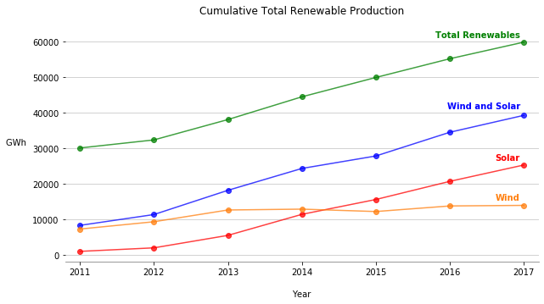

In the following charts, each dot represents an hour of continuous energy production at the corresponding Megawatt-hours (MWh) y-axis value. Every day of the year essentially has a vertical line of 15 dots (15 hours from 6AM to 8PM), color coded for what portion of the day it falls into, set at a height equivalent to the value of the MWh production for that hour. Note the scale of the y-axis in the following two graphs as they illustrate the growth in solar production between 2012 and 2017. The 2017 graph is nearly 10 times the scale of the 2012 graph. The increased production at midday and in the sunnier months can also be seen.

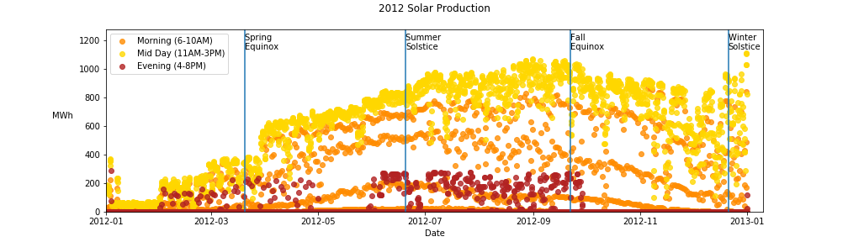

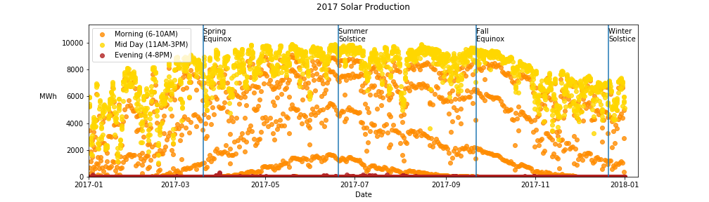

When comparing solar power’s nearly 10x growth from 2012 to 2017, the following graphs of wind production across 2012 and 2017 further demonstrate that the bulk of the renewable energy growth in the CAISO grid is coming from solar power, not wind. Another interesting observation between the wind and solar scatter plots across 2012 and 2017 is that the majority of the higher MWh production values for solar power are in the midday period (11AM-3PM), while wind has most of its larger MWh production values in the evening time block (4-8PM).

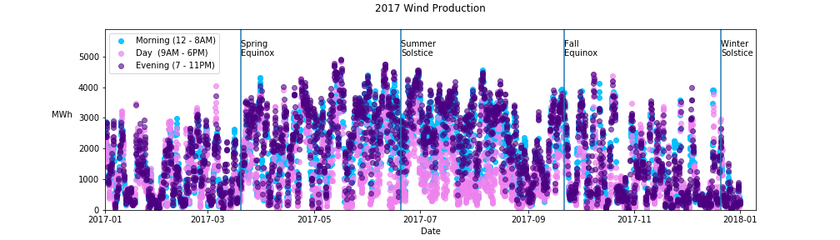

In the last two scatter plots comparing total renewable energy production in 2012 and 2017, the most obvious change is the 2012 scatter follows a pattern more similar to the wind power production graphs, while 2017’s pattern is more like the solar power production pattern. The scale of the y-axis is important to pay attention to in this graph as well.  The max values show nearly 3x growth in production across the year between 2012 and 2017.

**

Both the wind and solar scatter plots have values across the whole year that correspond to no energy production for that given hour (dots with y-value is 0). However, the plots for the total renewable energy production are consistently above 2,000 MWh.  This difference is due to the effect of other renewable sources (biogas, biomass, small hydro, and geothermal) that provide less overall energy than wind and solar.

**How does daily production fluctuate?**

The following visuals are box plots showing the mean value, outlier values, and quartile boundaries of the amount of energy produced across across every day in the 2010-2018 renewable energy Kaggle data set (2011-2017 were the only full years of data available).

Below, in the first visual showing solar production across the hours in a day, the obvious trend is what one would expect.  Solar power is being generated when the sun is up, and the peak production hours are in line with the peak sun intensity hours of the day (12 and 1 PM).  The large magnitude of the interquartile range shown in the solar plot is due to the huge increase in solar production across the span of the years in this data set.

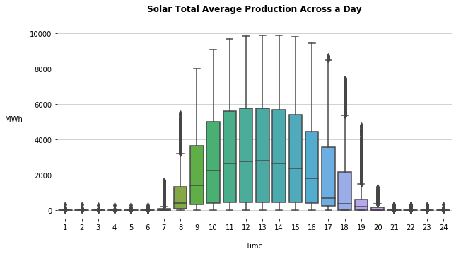

While looking at the next graph, showing the trend in wind production across a day, it is obvious that wind’s trend is almost the opposite of the above solar production graph.  The mean values for the peak production hours are significantly smaller for wind production than solar, but this is to be expected with the knowledge of solar power’s explosive in growth from 2012 to 2017.

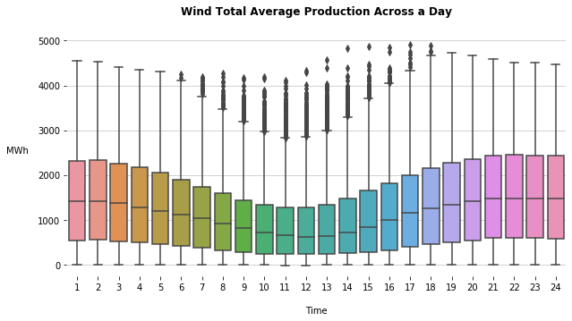

The final box plot below shows the trend in total energy produced from all renewable sources across a day. The general increase in production across the daytime hours of the day reflects the significant contribution solar power makes to California’s renewable energy production. Of note, the quartile ranges in this graph are significantly larger in the hours that solar is providing power, similar to the solar production per hour chart. This is because solar has had so much growth over the time period captured in our data set. Noting that when solar power is not online (when the sun is down), all the hours have relatively smaller interquartile ranges shines a light on another interesting observation. The lack of variance in hours when the renewable energy is coming from wind and all other smaller sources (biogas, biomass, etc.), clearly shows that these sources have grown less in energy produced from 2010-2018.  A topic that could be researched further would be the causal factors for the lack of growth in energy production from other renewable sources.

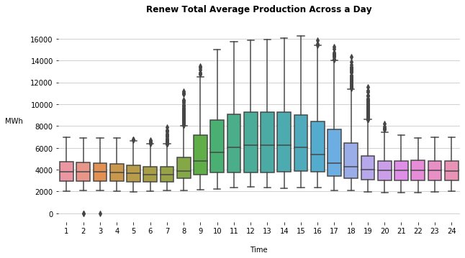

**How does monthly and hourly production in 2017 compare to 2012?**

When looking at energy production across the hours of a day, again the midday contribution from solar energy stands out. The main difference between 2012 and 2017 is the additional production that occurs during daylight hours in 2017.

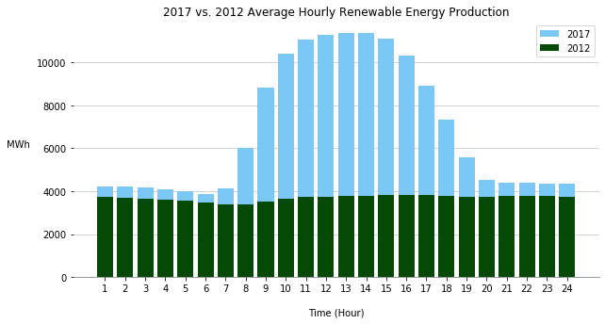

In terms of monthly production in 2012 compared to 2017, the chart below shows that the most power produced by renewables in 2012 was more than 3,000,000 in May and June. By 2017, renewables were producing about twice that amount for those months. The contributions of solar stand out again, as the most gains were made in typically sunnier months of the year.

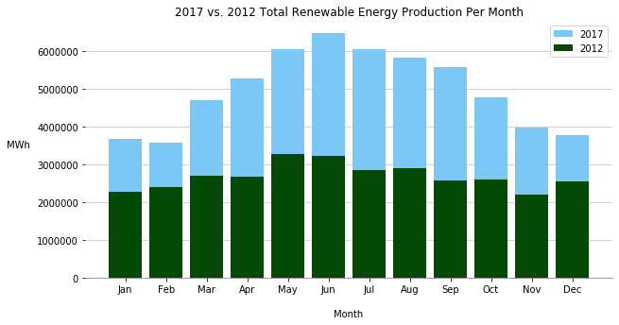

The growth in solar production from 2012 to 2017 is made even more clear in the following chart. The impact of seasonal changes also appears to limit the relative increase in solar production for the months with less daylight.

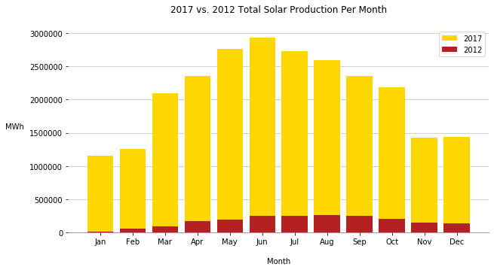

**What percent of annual total energy demand is provided by renewables?**

By 2017, California was closer to meeting its goal of 33% renewable energy. On average in 2017, renewables provided 26% of energy. Since solar is the largest provider, it is not surprising that the smallest proportion of renewable energy was provided during the winter, when there are the fewest hours of daylight. Sunny, but not too warm spring, was the period when renewables contributed the highest proportion of energy, with 32% in April and May.

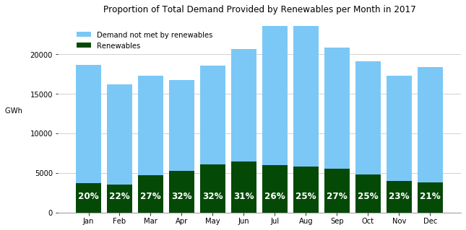

**What is the snapshot of renewable energy contributions on a peak load day?**

We used CAISO data to identify the day with the highest energy demand for our study period, which was September 1, 2017. As expected, renewables contributed the most energy during the daylight hours and contributed the highest proportion of energy (35%) at 9 a.m.. At the hour of peak demand (5 p.m.) renewables contributed only 16%. With the sun still shining, it appears there was additional opportunity for solar contribution at the peak load hour.

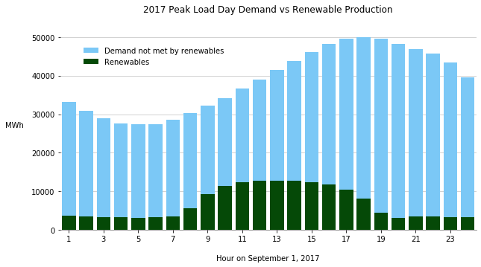

**Combined Smaller Renewable Resources:**

Below is a box plot of combined hourly production of the renewable sources not focused on in this analysis. The cumulative power production values from these resources are included in any chart showing “Total Renewables”, but these sources remain relatively constant, so they aren’t focused on. The combined sources charted below are compiled from the hourly sum of production from biogas, biomass, small hydro, and geothermal across all years in the Kaggle data set.

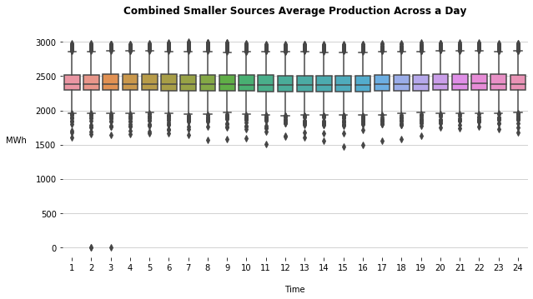

Below is a scatter chart similar to the solar power, wind, and total renewable scatter plots, showing the combined production of the same smaller renewable sources as above. Simply to show they stay relatively constant across the year and don’t have much hourly/ seasonal fluctuation.

